System Firmware Update Instructions for Pioneer In-Dash AV Receivers
(AVH-Z7250BT, AVH-Z5200DAB, AVH-Z5250BT, AVH-Z2250BT)

This firmware update (version 8.04) applies only to the following models of Pioneer In-Dash AV Receivers sold in Australia & New Zealand.

AVH-Z7250BT
AVH-Z5200DAB
AVH-Z5250BT
AVH-Z2250BT

IMPORTANT
Please download and print these firmware update instructions before downloading and installing the firmware update. It is important that you complete all steps correctly and in the order described below.

Note: If you have any questions, please contact Pioneer Customer Service at 1800 988 268, Monday through Friday, 9:00 AM - 5:00 PM, excluding holidays.

In order to perform this update, the following items are needed:
- Pioneer In-Dash AV receiver listed above.
- A USB storage device meeting the following requirements:
- 2 GB or larger in capacity, formatted to FAT32
- Blank (should not contain any files)

CAUTION
- DO NOT turn your unit off or eject the USB storage device while the firmware is being updated.
- You can only update the firmware when the vehicle is stopped and the parking brake is engaged.

Checking the firmware version
Check whether the firmware of your unit needs to be updated by checking the version number of the firmware.

Procedure:
- Press the HOME button to display the menu screen.
- Touch the following keys in the following order.
The “System” screen appears.
- Scroll down the list and touch [System Information].
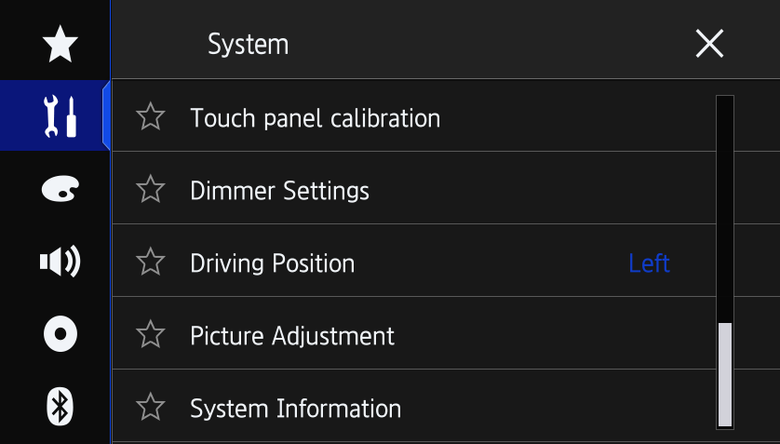
- Touch [Firmware information].
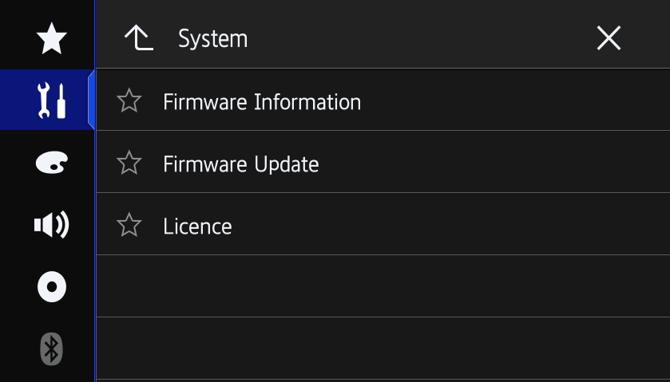
- After the “Firmware Information” screen appears, check the firmware version number.
- Verify that the firmware on your unit is not already 8.04.
Downloading the firmware update files from Pioneer's website

- Download the firmware update files by clicking on the following link and finding your product: https://www.pioneer.com.au/firmwaresoftware/
- Extract the download file.
The downloaded zip file will produce the following file when decompressed: (See the table below)

AVH-Z7250BT | CVJ3251-B.avh
AVH-Z5200DAB | CVJ3247-B.avh
AVH-Z5250BT
AVH-Z2250BT

Updating the firmware on your unit

IMPORTANT
AVH-Z7250BT
AVH-Z5200DAB
AVH-Z5250BT
AVH-Z2250BT

- DO NOT perform this firmware update if the model number of your Pioneer product is anything other than one of the above models.
- Ensure that the update file is located within the root (top) folder of your USB storage device. There should be no other files within the USB storage device.
- While your unit is being updated, DO NOT turn off the system’s power and DO NOT touch the unit’s touchscreen as this may result in severe damage to your unit.
- DO NOT remove the USB storage device during the firmware update process.
- Performing the firmware update will restore all settings to their default values.
- Disconnect any external mobile devices that are currently connected to your unit.

Procedure:
  - Connect a blank (formatted) USB storage device to your computer, and then locate the correct update file and copy it onto the USB storage device.
  - Connect the USB storage device to the USB port.
  - Set the audio source to “OFF” on your unit.
  - Press the HOME button to display the menu screen.
  - Touch the following keys in the following order.
The “System” screen appears.
  - Scroll down the list and touch [System information].
  - Touch [Firmware Update].
The “Firmware Update” screen appears.
  - Touch [Continue] to display the data transfer mode.
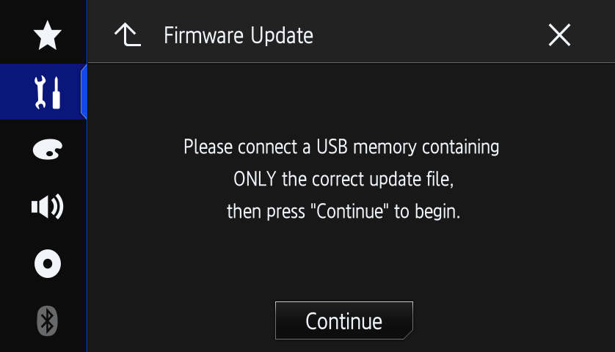
  - Read the “WARNING,” then touch the [Start] button to start the update process. If it shows “ERROR” on the display, try another USB device.
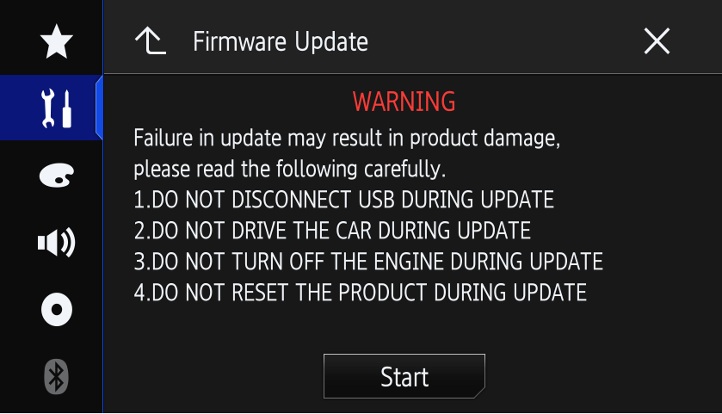
  - After starting, there will be a progress bar while updating. (Please note: version number will differ from image below.)
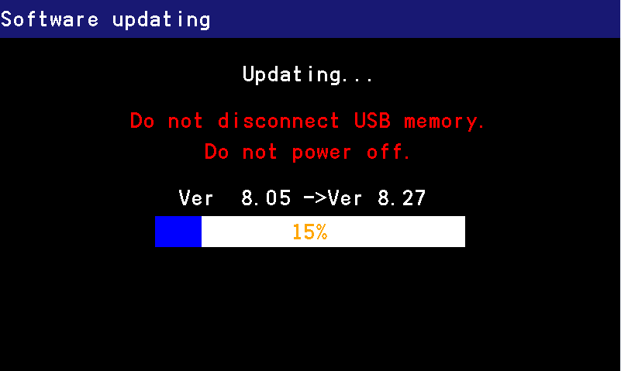
*The version of this picture is just reference.
  - Display will show “It succeeded…” when the update is complete.
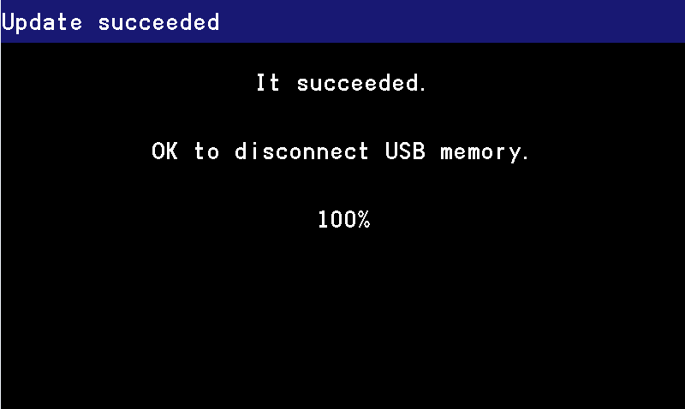

  - The product will reboot after the update is finished. Do not touch anything even when the screen is blacked out. After it has finished rebooting, the screen will return to the menu screen.

  - The firmware update is now complete. Your Pioneer AV Receiver is now ready for use.

Confirm that the firmware has been updated
Perform the same procedure for “Displaying the firmware version” to confirm that the firmware has been updated.

Procedure:
- Press the HOME button to display the menu screen.
- Touch the following keys in the following order.
The “System” screen appears
- Scroll down the list and touch [System Information].
- Touch [Firmware information].
- After the “Firmware Information” screen appears, check the firmware version number.

If you have any difficulty performing these instructions, please contact Pioneer Customer Service at 1800 988 268, Monday through Friday, 9:00 AM - 5:00 PM, excluding holidays.

------------------------------------------------------------
Copyright 2018 Pioneer Corporation

